AN EQUAL AREA HEXAGONAL
SAMPLING FRAMEWORK
FOR CANADA
____________________________________________________

OBJECTIVE S

- To construct an equal-area geo-referenced sampling grid for Canada.
- To grid ecoregions and available range maps for common species and species-at-risk (designated by Committee on the Status of Endangered Wildlife in Canada; COSEWIC) in Canada.

METHODS

- An equal-area grid of 10,000 km² hexagons was constructed on a Lambert azimuthal equal-area map projection.
- The ranges of 697 common and COSEWIC mammals, birds, reptiles, and amphibians, and COSEWIC fish, plants, lepidoptera and molluscs were transferred to the equal-area grid.
- The areas of 217 ecoregions were also transferred to the equal-area grid.

INTRODUCTION

Considerable attention has been focused on the conservation and management of biodiversity in Canada, particularly since signing the Convention on Biological Diversity in 1993 and its subsequent ratification. A recent international scientific review of biodiversity (Heywood & Watson, 1995), clearly indicates that past and projected human induced stresses pose significant risks to the biodiversity and functioning of ecosystems. These and other agreements and reviews (e.g. Environment Canada, 1994; CFS, 1997) emphasize the need to assess the status of biodiversity and to better understand the causes and consequences of changes in biodiversity. Furthermore, the economic benefits of conserving biodiversity are beginning to be recognised and documented (Perrings et al., 1995; Arrow et al., 1995).

Canada was the first industrialised nation to sign the Convention on Biological Diversity. Canadians are concerned about the degradation of ecosystems and loss of biodiversity from human activities for aesthetic, economic, ecological, cultural and educational reasons (BCO, 1995; Heywood & Watson, 1995). For example, degraded forest, agricultural and aquatic ecosystems are less productive and require greater inputs if they are to continue supporting the wildlife and human communities that depend on them. All of these concerns are ultimately related to the loss of genetic diversity, the primary raw material that is filtered by natural selection, resulting in evolutionary and ecological adaptation of biota to environmental conditions. Minimising additional loss of biodiversity will provide the best assurance that biota will adapt to the increasing rate and spatial extent of environmental change (Pratt & Cairns, 1992), and that societal values can be sustained.

Achieving the vision outlined in the Canadian Biodiversity Strategy (BCO, 1995) requires multiple-scale hierarchical approaches. Such approaches are inter-disciplinary and should include contributions from ecology, geography, agriculture and forest science, and social sciences such as economics, sociology and land-use planning (White et al., 1999). With collaboration from many perspectives, more appropriate databases and analytic approaches can be formulated. More significantly, a co-operative, cross-sectoral approach based on partnerships promises better linkage between scientific perspectives and the spatial, temporal, and political structure of decision-making (Lubchenco, 1995). Clarifying the scientific status of biodiversity can set the stage for moving the biodiversity debate from one primarily about the facts of the issue to one about values (c.f. Williams & Gaston, 1994; Williams et al., 1996).

In this project, we extend and apply new methods of spatial analysis for geo-referenced data in order to identify important areas for achieving national conservation goals. In other words, with limited resources to study or conserve biodiversity, we ask where are the best places for further investigation or conservation activity? At the national scale, our analyses will identify priority regions for conservation effort. Within regions, the study will identify locations of potential sites for conservation efforts such as establishing a network of protected areas representative of regional biodiversity, or implementing changes to forestry or agricultural practices that could benefit biodiversity. While protected areas are a key component to a biodiversity conservation strategy, their long-term value will depend on sound stewardship in remaining, and particularly adjacent, areas (Pressey et al., 1995; Flather et al., 1997). To improve the network of protected areas in Canada, comprehensive criteria need to be developed for determining priority sites for further conservation action. Examples of such sites might be areas supporting a high diversity of species, migratory species, representative species, or unique species (BCO, 1995) that occur outside current protected areas. This project will extend the focus of biodiversity conservation and management beyond from multiple single-species approaches to a single multiple-species approach. Analyses will provide insights into the ability of sites to contribute to the representation of biodiversity at the national scale, and indicate gaps in existing conservation and management strategies. The approaches developed will aid in the process of decentralising resource management decision-making to the community level, while maintaining the larger-scale perspective necessary for integrated planning to ensure sustainable resource use.

METHODS

Geospatial Sampling Framework
For large-scale studies of the distribution of biodiversity, an analysis structure that provides comparability is desirable (White et al., 1999). This study used a sampling framework that is similar to one that was designed to provide a regular, systematic, hierarchical hexagonal spatial structure for environmental monitoring and assessment by the U.S. Environmental Protection Agency (White et al., 1992). The hexagon tessellation is attractive because it minimises spatial distortion and, if constructed on an equal-area map projection, provides an equal-area sample (White et al., 1992). Furthermore, hexagons are generalisable to both larger and smaller spatial scales. This becomes important for extending regional and national assessments to continental and global scales. An equal-area grid also provides a common spatial unit for comparison of diverse data types whereas ecoregions, for example, are not comparable but by definition unique. Equal-area units also minimise confounding due to species-area relationships, a potential problem if other units such as ecoregions (Moore, 1997; Ricketts et al., 1999) or counties (Dobson et al., 1997) are used. Because an equal area sampling framework largely ignores jurisdictional boundaries, it can help focus the biodiversity debate on the facts of the issue rather than the politics.

The sampling framework (see Map 1) was a grid of hexagons, each 10,000 km² in area (White 1999). We chose the 10,000 km² scale for our grid because, in our judgement, it best suited the scale of the range data available for the majority of taxa. There were 1275 hexagons that were completely or partly enclosed by the terrestrial political boundaries of Canada.

The grid provided an accounting mechanism that served several purposes (White et al., 1999). First, a single set of analysis units facilitated comparison of different data sets. Second, the uncertainty inherent within available range maps could be minimised by limiting the precision of location assignment to this scale. Furthermore, concerns about the confidentiality of precise locations of occurrence for species of concern (e.g. endangered species) was alleviated by using a 10,000 km² grid. Finally, there is a strong argument for generalising species distributions from the precise data of field observations in order to account for the biases in observation locations.

The size of the hexagons thus reflects a compromise between the desire for spatial detail and the constraints of reasonable spatial representation of species life histories, data collection, confidentially, and computational feasibility. Solutions to spatial analyses can depend, of course, on the sizes of units used (Stoms, 1994).
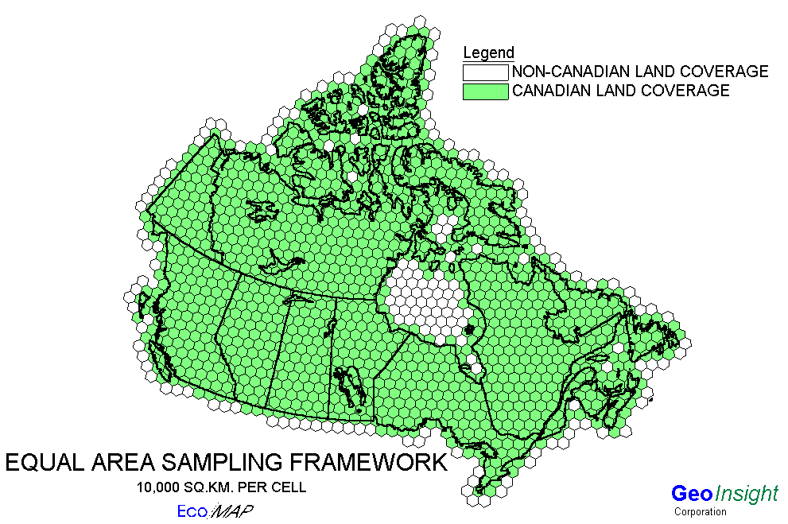

Map 1. Equal area hexagon grid of Canada
Species richness
We used range data for 796 species (summary in Table 1) from two sources. The ranges of terrestrial mammals, birds, amphibians, reptiles, fish, plants, molluscs and lepidoptera listed as endangered, threatened, or vulnerable by the Committee on the Status of Endangered Wildlife in Canada (hereinafter termed ‘COSEWIC’) were provided to us by that organisation. Information contained in each COSEWIC species report was used to generate range maps. For example, sometimes there was specific coordinate data from field surveys which could be mapped directly (most common with plant data). Other reports had range maps attached which were digitized for GIS input. While still other reports only had a discripition of the range which had to be transfered to maps before digitizing at 1:1,000,000 scale. The ranges of ‘common’ (i.e. not listed by COSEWIC) mammals, birds, amphibians and reptiles were digitised from published range maps. For Mammals, Reptiles and Amphibians paper range maps were provided by the Canadian Museum of Nature from their publications "Mammals of Canada" and "Introduction to Canadian Amphibians and Reptiles". For the common bird range maps digital files for summer, winter and all-year ranges were provided by the Canadian Wildlife Service (Ontario Region). In this study the summer and all-year ranges were combined to represent the areas in Canada where the species may be found breeding. Where range-maps specified winter-only ranges for birds these areas were not included in our analyses. Although marine species were excluded from our analyses, some coastal bird species that also breed inland were included.

Table 1. Number of species used in preliminary analyses.

Status
Taxon Common Endangered Threatened Vulnerable Total

Mammals 123 5 5 19 152
Birds 342 14 7 20 383
Amphibians 37 2 0 7 46
Reptiles 33 2 4 7 46
Fish - 4 15 39 58
Plants - 33 36 38 107
Molluscs - 1 1 0 2
Lepidoptera - 1 0 1 2

Total 535 62 68 131 796

The presence of species in each of the 1,275 hexagons was determined using GIS overlay methods and formed the data used in subsequent analyses. Species richness per hexagon for different
taxa was mapped using SPANS (examples in Map 2)

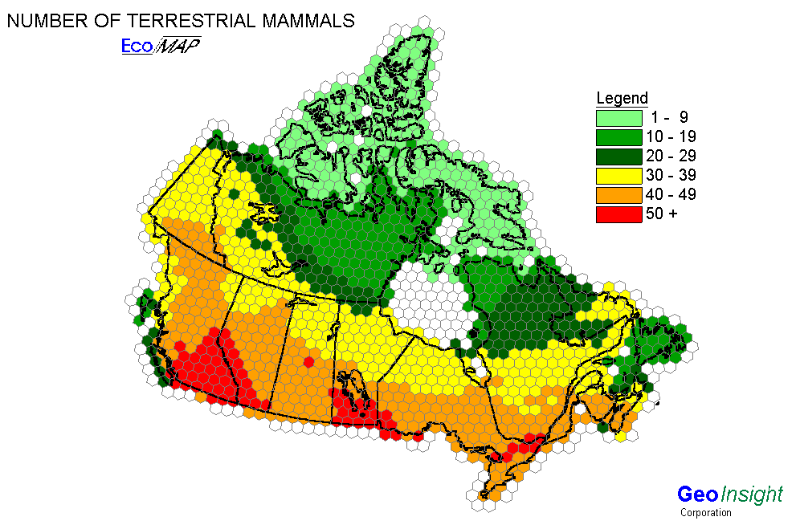
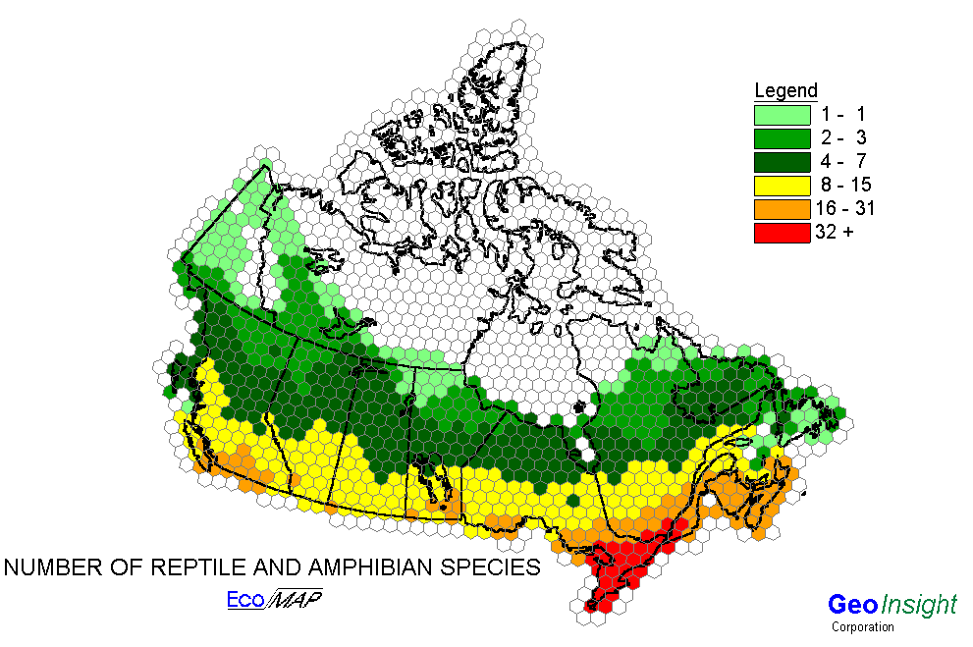

Map 2A
Map 2B

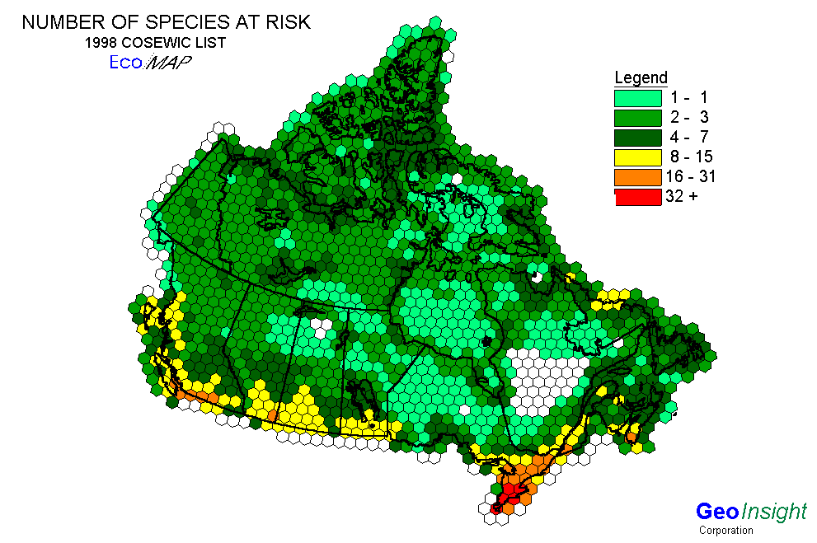
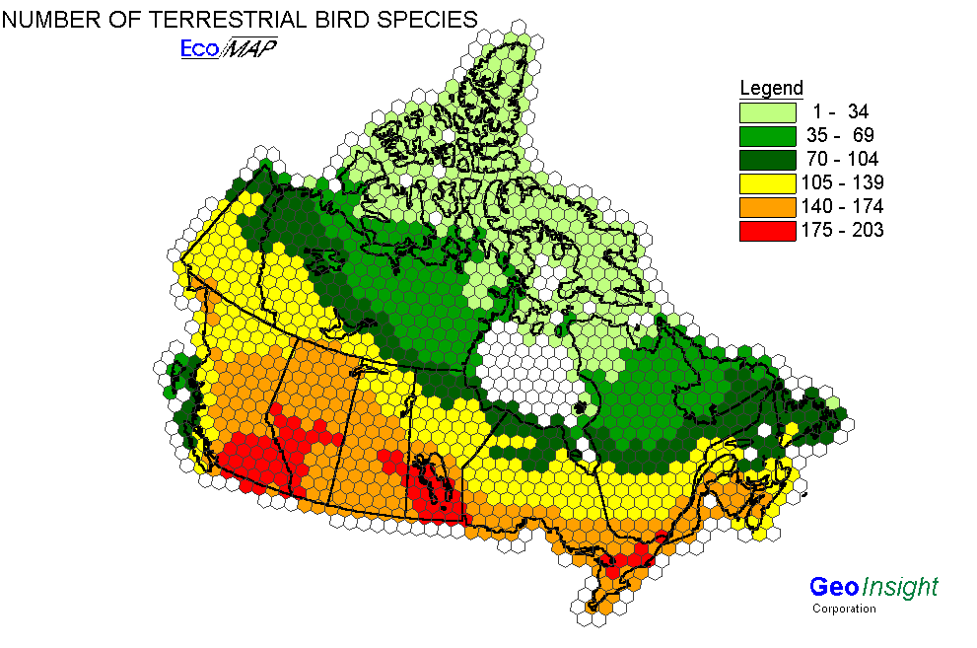

Ecoregions

In Canada, a conservation target of 12% has been specified for representing each of the country’s ecosystems in protected areas (Turner et al., 1992). The representation of distinct ecological areas has been assumed to also represent species diversity (e.g. Turner et al., 1992; Ricketts et al., 1999), although the limited empirical evidence does not support this, at least at small scales (Ferrier and Watson, 1997). Hence, a further objective of this study was to evaluate the effectiveness of using a target of 12% of each ecoregion area for achieving representation of the 796 taxa described above.

Canada has been classified into a total of 217 ecoregion areas based upon spatial differences in both abiotic and biotic factors (Map 3). Ecoregions are “characterised by distinctive large order landforms or assemblages of regional landforms, small order macro- or mesoclimates, vegetation, soils, water, and regional human activity patterns/uses” (Ecological Stratification Working Group, 1996). For a detailed description of ecoregions see Ecological Stratification Working Group (1996). The area of each ecoregion present within hexagons was calculated from maps provided by the Agriculture and Agri-Food Canada, Research Branch, Centre for Land and Biological Resources Research and Environment Canada, State of the Environment Directorate, Ecozone Analysis Branch, Ottawa/Hull.

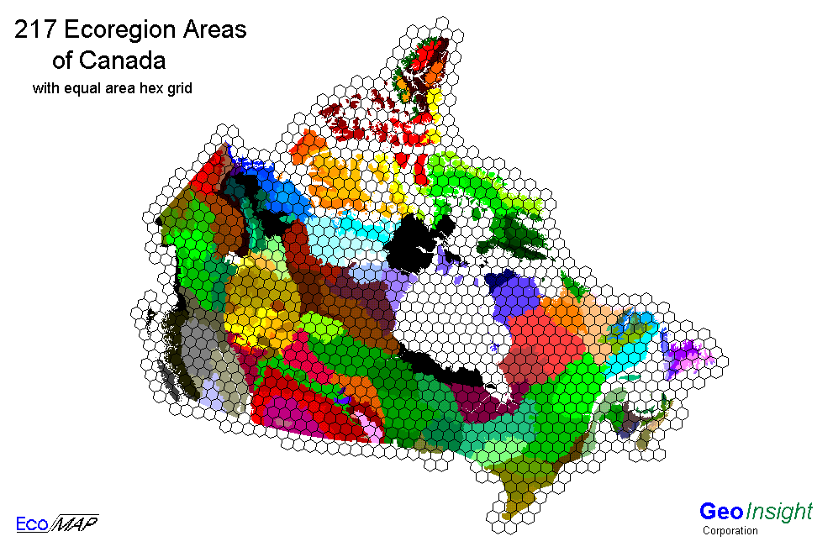

Map 3. The hexagon grid over the 217 ecoregions in Canada

Human factors

As a measure of human pressures on the environment the population for each of the hex cells was derived from the 1996 census of population, and the length of roads in each hex cell was derived from the National Roads Database as reported by NTS map sheet. These two values provide a measure of where the pressures from human population are and where the greatest levels of access are.

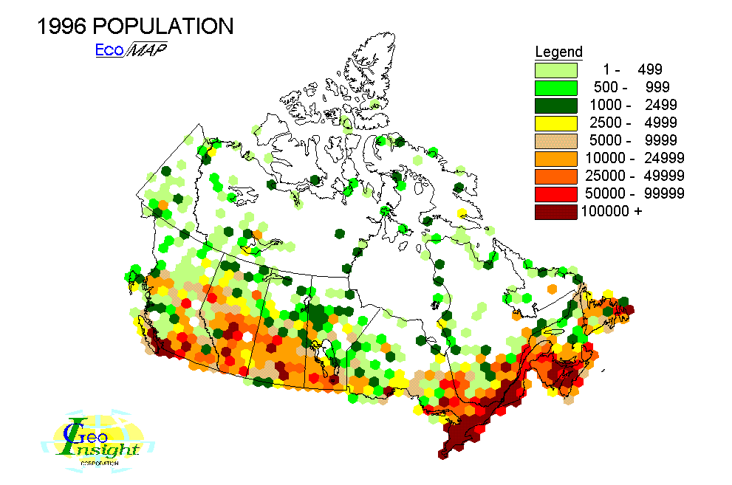
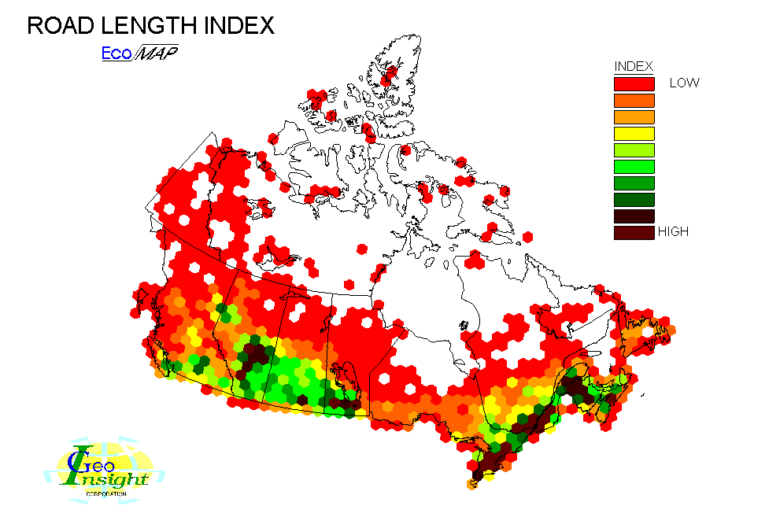

Hexgrid database:

The hex grid framework is provided as an AecInfo export format (E00). The data attribute database contains the following layers.

- HEXCELL---hexcell entity number
- LON.----------centroid longditude
- LAT.----------centroid latitude
- HEXNUM----hex cell number
- COSEWIC---number of species at risk (COSEWIC 1998)
- BIRDS--------number of terrestrial bird species
- MAMMALS-number of terrestrial mammal species
- REP_AMPH-number of reptile and amphibian species
- INDUST-----number of industrial discharge sites (air)
- ENDEMICP-number of endemic plant species
- RAREPLT--number of rare plant species
- LANDDIVR-number of avhrr landcover classes
- PROTAREA-area of protected land from Canadian Conservation Areas Database (sq.km.)
- TREES--------number of tree species
- CENS96PO---population from 1996 census
- ROADLEN---road length index, computed from Canadian Roads Database on road length per NTS map sheet

PROJECT PARTNERS

Harold Moore  GeoInsight Limited  PO Box 24196  Hazeldean RPO  Kanata, ON K2M 2C3  Canada | Kathryn Freemark  National Wildlife Research Centre  Canadian Wildlife Service  Environment Canada  Hull, QU K1A 0H3  Canada
David Forsyth, Anthony Sinclair  Centre for Biodiversity Research  University of British Columbia  Vancouver, BC V6T 1Z4  Canada | Denis White  U.S. Environmental Protection Agency  Corvallis, OR 97333  USA
Tom Barrett, Robert Pressey
New South Wales National Parks & Wildlife Service
Armidale, NSW 2350

Australia

Funding was provided by the Geomatics Development Program of Natural Resources Canada under contract # 23333-8-E137/001/SQ to GeoInsight Corp. and by the Migratory Birds Populations Division at the National Wildlife Research Centre, Canadian Wildlife Service, Environment Canada, Hull, Quebec. David M. Forsyth was supported by a New Zealand Foundation for Research and Technology Post-Doctoral Fellowship.

REFERENCES

Arrow, K., B. Bolin, et al. 1995. Economic Growth, Carrying Capacity, and the Environment.
Science 268: 520 521.
Banfield, A.W.F. 1977. The Mammals of Canada. University of Toronto Press, Toronto.
BCO, 1995. Canadian Biodiversity Strategy: Canada’s Response to the Convention on
Biological Diversity. Biodiversity Convention Office, Environment Canada, Hull, Quebec.
Camm, J.D.; S. Polasky; A. Solow; B. Csuti. 1996. A note on optimal algorithms for reserve site
selection. Biological Conservation 62: 115-125.
CFS. 1997. Biodiversity in the Forest: Implementing the Canadian Biodiversity Strategy. Science
Branch, Canadian Forest Service, Natural Resources Canada, Ottawa.
Cook, F.R. 1984. Introduction to Canadian Reptiles and Amphibians. National Museum of Natural Sciences, Ottawa.
Commission for Environmental Cooperation. 1997. Ecological regions of North America:
toward a common perspective. Commission for Environmental Cooperation, Montréal. 71pp.
Csuti, B.; S. Polasky; P.H. Williams; R,L. Pressey; J.D. Camm; M. Kershaw; A.R. Kiester; B.
Downs; R. Hamilton; M. Huso; K. Sahr. 1997. A comparison of reserve selection algorithms using data on terrestrial vertebrates in Oregon. Biological Conservation 80: 83-97.
Dobson, A.P.; J.P. Rodriguez; W.M. Roberts; D.S. Wilcove. 1997. Geographic distribution of
endangered species in the United States. Science 275: 550-553.
Dunn, E. H., 1997. Setting priorities for conservation, research and monitoring of Canada’s
landbirds. Technical Report No. 293, Canadian Wildlife Service, Headquarters, Environment Canada, Hull, Quebec.
Ecological Stratification Working Group. 1996. A national ecological framework for Canada.
Agriculture and Agri-Food Canada, Research Branch, Centre for Land and Biological Resources Research and Environment Canada, State of the Environment Directorate, Ecozone Analysis Branch, Ottawa/Hull.
Environment Canada. 1994. Biodiversity in Canada: A Science Assessment for Environment
Canada. Ottawa, ON. 245 pp.
Erasmus, B.F.N.; S. Freitag; K.J. Gaston; B.H. Erasmus; A.S. Van Jaarsveld. 1999. Scale and conservation planning in the real world. Proceedings of the Royal Society of London B 266: 315-319.
Faith, D.P.; P.A. Walker. 1996. How do indicator groups provide information about the relative biodiversity of different sets of areas? On hotspots, complementarity and pattern-based approaches. Biodiversity Letters 3: 18-25.
Ferrier, S.; G. Watson. 1997. An evaluation of the effectiveness of environmental surrogates and
modelling techniques in predicting the distribution of biological diversity. Biodiversity Group, Environment Australia. 193 pp.
Ferrier, S.; R.L. Pressey; T.W. Barrett. In press. A new predictor of the irreplaceaility of areas for achieving a conservation goal. Biological Conservation.
Finkel, E. 1998. Software helps Australia manage forest debate. Science 281: 1789-1791.
Flather, C.H.; K.R. Wilson; D.J. Dean; W.C. McComb. 1997. Identifying gaps in conservation
networks: Of indicators and uncertainty in geographic-based analyses. Ecological Applications 7: 531-542.
Flather, C.H.; M.S. Knowles; I.A. Kendall. 1998. Threatened and endangered species geography.
BioScience 48: 365-376.
Gaston, K.J. 1994. Rarity. Chapman and Hall, London.
Heywood, V. H.; R. T. Watson. 1995. Global Biodiversity Assessment. Cambridge University
Press, New York.
Howard, P.C.; P. Viskanic; T.R.B. Davenport; F.W. Kigenyi; M. Baltzer; C.J. Dickinson; J.S.
Lwanga; R.A. Matthews; A. Balmford. 1998. Complementarity and the use of indicator groups for reserve selction in Uganda. Nature 394: 472-475.
Kershaw, M.; P.H. Williams; G.C. Mace. 1994. Conservation of Afrotropical antelopes:
consequences and efficiency of using different site selection methods and diversity
criteria. Biodiversity and Conservation 3: 354-372.
Kiester, A. R.; J. M. Scott; B. Csuti; R. Noss; B. Butterfield; K. Sahr; D. White. 1996.
Conservation prioritization using GAP data. Conservation Biology 10: 1332-1342.
Lawton, J.H. 1993. Range, population abundance and conservation. Trends in Ecology and Evolution 8: 409-413.
Lawton, J.H. 1995. Population Dynamic Principles. In Lawton, J.H.; R.M. May (Eds.). Extinction Rates. Oxford University Press, Oxford.
Lawton, J.H.; D.E. Bignell; B. Bolton; G.F. Bloemers; P. Eggleton; P.M. Hammond; M. Hodda;
R.D. Holt; T.B. Larsen; N.A. Mawdsley; N.E. Stork; D.S. Srivastava; A.D. Watt. 1998. Biodiversity inventories, indicator taxa and effects of habitat modification in tropical forest. Nature 391: 72-76.
Lombard, A.T. 1995. The problems with multi-species conservation: do hotspots, ideal reserves
and existing reserves coincide? South African Journal of Zoology 30: 145-163.
Lubchenco, J., 1995. The role of science in formulating a biodiversity strategy. BioScience,
Supplement: 7-9.
Margules, C.R.; A.O. Nicholls; R.L. Pressey. 1988. Selecting networks of reserves to maximize
biological diversity. Biological Conservation 43: 63-76.
Moore, H.D. et al, 1997. Risk to Biodiversity Report to Indicators and Assessment Office Environment Canada
Norušis, M.J. 1998. SPSS® 8.0 Guide to Data Analysis. Prentice Hall, New Jersey.
Peterson, R.T. 1990. A Field Guide to Western Birds. Third edition. Houghton Mifflin, Boston.
Perrings, C., K. G. Maler, et al. (eds.). 1995. Biodiversity Loss: Economic and Social Issues.
Cambridge University Press, Cambridge, UK.
Prendergast, J.R.; R.M. Quinn; J.H. Lawton; B.C. Eversham; D.W. Gibbons. 1993. Rare
species, the coincidence of diversity hotspots and conservation strategies. Nature 365: 335-7.
Pratt, J. R.; J. Cairns Jr., 1992. Ecological risks associated with the extinction of species. In J. Cairns, Jr., B. R. Niederlehner & D. R. Orvos (ed.). Predicting Ecosystem Risk. Princeton Scientific Publishing Co., Princeton, New Jersey, pp. 93-117.
Pressey, R. L. 1997. Priority conservation areas: towards an operational difinition for regional
assessments. In J.J. Pigram and R.C. Sundell (eds.). National Parks and Protected Areas: Election, Delimitation and Management. Centre for Water Policy Research, University of New England, Armidale, Australia, pp. 337-357.
Pressey, R. L. 1998. Algorithms, politics and timber: an example of the role of science in a public, political negotiation process over new conservation areas in production forests. In R. Wills and R. J. Hobbs (ed.). Ecology for Everyone: Communicating Ecology to Scientists, the Public and the Politicians. Surrey Beatty & Sons, Sydney, Australia, pp. 73-87.
Pressey, R.L; K.H. Taffs. In review. Priority conservation areas: a definition for the real world
applied to western New South Wales. Biological Conservation.
Pressey, R.L.; I.R. Johnson; P.D. Wilson. 1994. Shades of irreplaceability: towards a measure of
the contribution of sites to a reservation goal. Biodiversity and Conservation 3: 242-262.
Pressey, R.L; H.P. Possingham; J.R. Day. 1997. Effectiveness of alternative heuristic algorithms
for identifying minimum requirements for conservation reserves. Biological Conservation 80: 207-219.
Pressey, R.L; H.P. Possingham; C.R. Margules. 1996. Optimality in reserve selection
algorithms: When does it matter and how much? Biological Conservation 76: 259-267.
Pressey, R. L.; C. J. Humphries; C. R. Margules; R. I. Vane-Wright;. P. H. Williams. 1993.
Beyond opportunism: key principles for systematic reserve selection. Trends in Ecology
and Evolution 8: 124-128.
Pressey, R. L.; S. Ferrier; C.D. Hutchinson; D.P. Sivertsen; G. Manion. 1995. Planning for
negotiation: using an interactive geographic information system to explore alternative
protected area networks. In D. A. Saunders, J. L. Craig & E .M. Mattiske
(ed.). Nature Conservation 4: The Role of Networks, Surrey Beatty & Sons, Sydney, Australia, pp. 23-33.
Pulliam, H. R.; B. Babbitt. 1997. Science and the protection of endangered species. Science
275: 499-500.
Reid, W.V. 1998. Biodiversity hotspots. Trends in Ecology and Evolution 13: 275-280.
Ricketts, T.H.; E. Dinerstein; D.M. Olson; C. Loucks. 1999. Who’s where in North America? BioScience 49: 369-381.
Ryti, R.T. 1992. Effect of the focal taxon on the selection of nature reserves. Ecological Applications 2: 404-410.
Scott, W. B.; E. J. Crossman. 1973. Freshwater fishes of Canada. Fisheries Research Board of Canada Bulletin 184: 1-966.
Stoms, D., 1994. Scale dependence of species richness maps. Professional Geographer 46: 346-
358.
Turner, A.M.; C.D.A. Rubec; E.B. Wiken. 1992. Canadian ecosystems: a systems approach to
their conservation. Developments in Landscape Management and Urban Planning 7:
117-127.
Van Jaarsveld, A.S.; S. Freitag; S.L. Chown; C. Muller; S. Koch; H. Hull; C. Bellamy; M. Krüger; S. Endrödy-Younga; M.W. Mansell; C.H. Scholtz. 1998. Biodiversity assessment and conservation strategies. Science 279: 2106-2108.
White D. (In press.) Global grids from recursive diamond subdivisions of the surface of an octahedron or icosahedron. Environmental Management and Assessment.
White, D.; A.J. Kimerling; W.S. Overton. 1992. Cartographic and geometric components of a
global sampling design for environmental monitoringCartography and Geographic Information Systems 19: 5-22.
White D, E. M. Preston, K. E. Freemark, A. R. Kiester. 1999. A hierarchical framework for conserving biodiversity. Landscape ecological analysis: issues and applications. In J M Klopatek, R H Gardner (editors). Springer-Verlag, New York, pp. 127-153.
Williams, P.; D. Gibbons; C. Margules; A. Rebelo; C. Humphries; R. Pressey. 1996. A
comparison of richness hotspots, rarity hotspots, and complementary areas for
conserving diversity of British Birds. Conservation Biology 10: 155-174.
Williams, P.H.; K.J. Gaston, 1994. Measuring more of biodiversity: Can higher-taxon
richness predict wholesale species richness? Biological Conservation 67: 211-217.
Williams, P. H., G. T. Prance, C. J. Humphries and K. S. Edwards, 1996. Promise and problems
in applying quantitative complementary areas for representing the diversity of some
Neotropical plants (families Dichapetalaceae, Lecythidaceae, Caryocaraceae,
Chrysobalanaceaeand Proteaceae). Biological Journal of the Linnaeus Society 58: 125-157.
Williams, P. H.; K. J. Gaston; C. J. Humphries. 1997. Mapping biodiversity value worldwide:
combining higher-taxon richness from different groups. Proceedings of the Royal Society
of London B 264: 141-148.
Zar, J.H. 1996. Biostatistical Analysis. Third edition. Prentice-Hall, New Jersey.

